vcpkg - package manager
Conteúdo

vcpkg - package manager 2
How vcpkg works 2
Pre-requisite 3
Clone vcpkg 3
Configure vcpkg 4
Environment update 4
Packages installation Path 4
Useful vcpkg commands 5
Installing a library from the vcpkg repository 7

vcpkg - package manager

vcpkg is a cross-platform command-line package manager for C and C++ libraries. It simplifies the acquisition and installation of third-party libraries on Windows, Linux, and macOS. If your project uses third-party libraries, we recommend that you use vcpkg to install them.
vcpkg supports both open-source and proprietary libraries.
All libraries in the vcpkg Windows catalog have been tested for compatibility with Visual Studio 2015, Visual Studio 2017, and Visual Studio 2019. Between the Windows and Linux/macOS catalogs, vcpkg now supports thousands of libraries. The C++ community adds more libraries to both catalogs on an ongoing basis.

https://docs.microsoft.com/en-us/cpp/build/vcpkg?view=msvc-160

How vcpkg works
The vcpkg project is open-source, available on GitHub. A clone or local copy of the vcpkg repo contains the vcpkg executable and a catalog, a list of packages that describe a library and its options. Each package includes one or more ports, information about how to obtain and build the library from sources, or download a binary version, for a specific target environment.
When you use vcpkg to install a library, it uses the package and port information to download and produce a local copy of the library in a subdirectory of the vcpkg directory, ready for you to use.
When a library is available in source form, vcpkg downloads sources instead of binaries. It compiles those sources using the most recent version of the C or C++ compiler and tools that it can find. For C++ ABI compatibility(*), it's important that both your application code and any libraries you use are compiled by the same version of the same compiler.
By using vcpkg, you eliminate or at least greatly reduce the potential for mismatched binaries and the problems they can cause.
In teams that standardize on a specific version of a compiler, one team member can use vcpkg to download sources and compile a set of binaries. It's inefficient to make everyone on a team download and build common libraries. One team member can use the vcpkg export command to create a common zip file of the binaries and headers, or a NuGet package. Then, it's easy to share it with other team members.

PS: it is a good practice to install all necessary libraries inside a sub-dir with short path names without spaces. Example: c:\src

(*)(application binary interface compatibility), for our purposes, refers to the ability to link pre-built (binary) libraries with arbitrary versions of a compiler

Pre-requisite
The vcpkg install procedure described here uses git command line. The git should be installed before as described by the “GitHub - command line” procedure inside the Visual Studio folder on my knowledge base.

Clone vcpkg
Clone the vcpkg repo from GitHub: https://github.com/Microsoft/vcpkg , as detailed on the following commands:
The figure Bellow illustrate how to check the latest vcpkg solution on the GitHub.
Use the commands listed bellow to clone vcpkg.

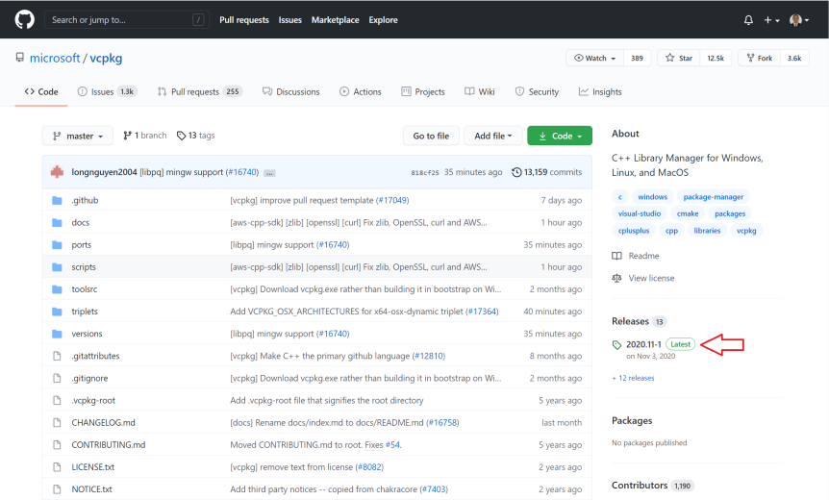

mkdir \src
cd \src
git clone https://github.com/microsoft/vcpkg

This command creates a local copy of the repo in a vcpkg subdirectory. This location is the vcpkg root directory for this clone of vcpkg.
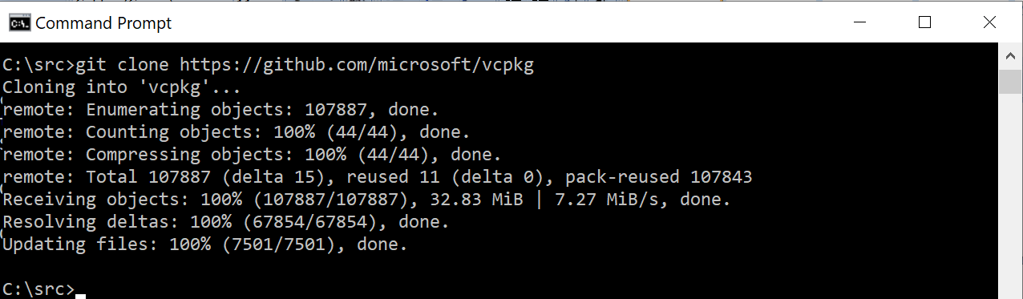

Configure vcpkg
In the vcpkg root directory, run the vcpkg bootstrapper command:
$ cd \src\vcpkg
$ bootstrap-vcpkg.bat

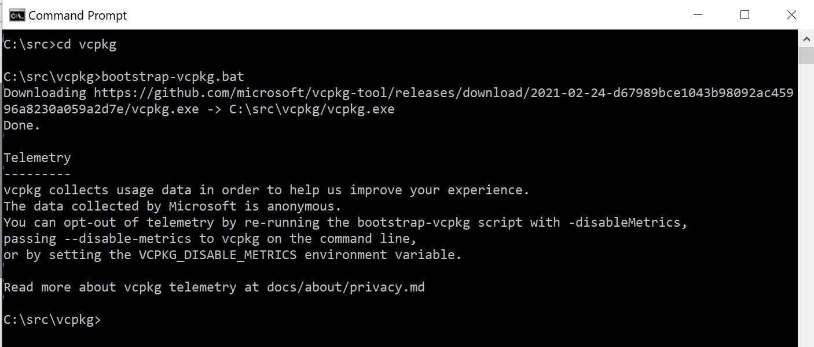

The bootstrapper configures vcpkg with the locations of the Microsoft C/C++ tools, libraries, and the Windows SDK. Once vcpkg is set up, you're ready to install libraries.

Environment update
Include the vcpkg on the env Path variable: Path: c:\src\vcpkg
Sign-out and sign-in again to update de environment variable Path.

Integrating vcpkg with VS on Windows
No diretório raiz do vcpkg, execute:
$ cd \src\vcpkg
vcpkg integrate install
Este comando irá configurar o Visual Studio para localizar todos os arquivos de cabeçalho e binários do vcpkg em uma base por usuário. Não é necessário editar os caminhos de diretórios do VC + + no Visual Studio. Se você tiver vários clones de vcpkg, o clone do qual executar esse comando se tornará o novo local padrão.
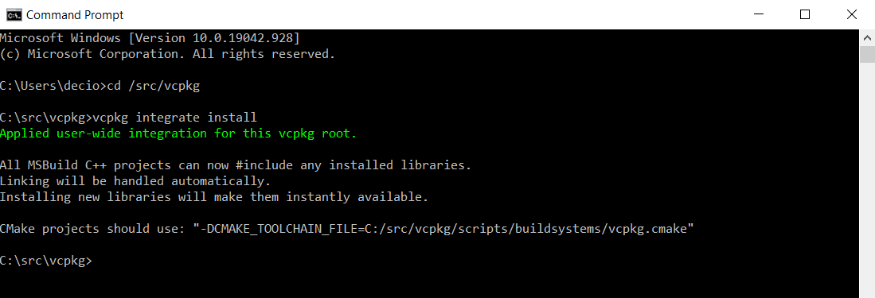

Packages installation Path
By default, all packages, will be installed inside the vcpkg directory: Example: c:\src\vcpkg
The “installed” packages will installed on the following directory:
C:\src\vcpkg\installed\<triplet platform>\<package name>

Useful vcpkg commands
List: List the libraries installed with vcpkg
c:\src\vcpkg\vcpkg list
List dependencies: List the libraries dependecies
c:\src\vcpkg\vcpkg depend-info <library_name>
Example: c:\src\vcpkg\vcpkg depend-info libwebsockets
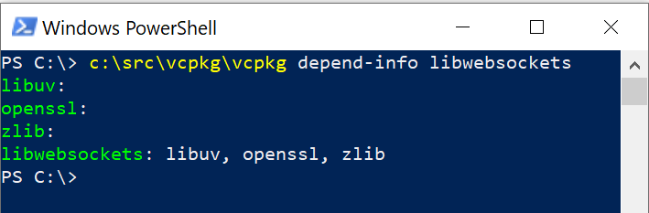
Search: Search for the name of a library available to be installed. Use the name returned by the search to install the library
c:\src\vcpkg\vcpkg search <pattern to search>
Example: c:\src\vcpkg\vcpkg search sockets
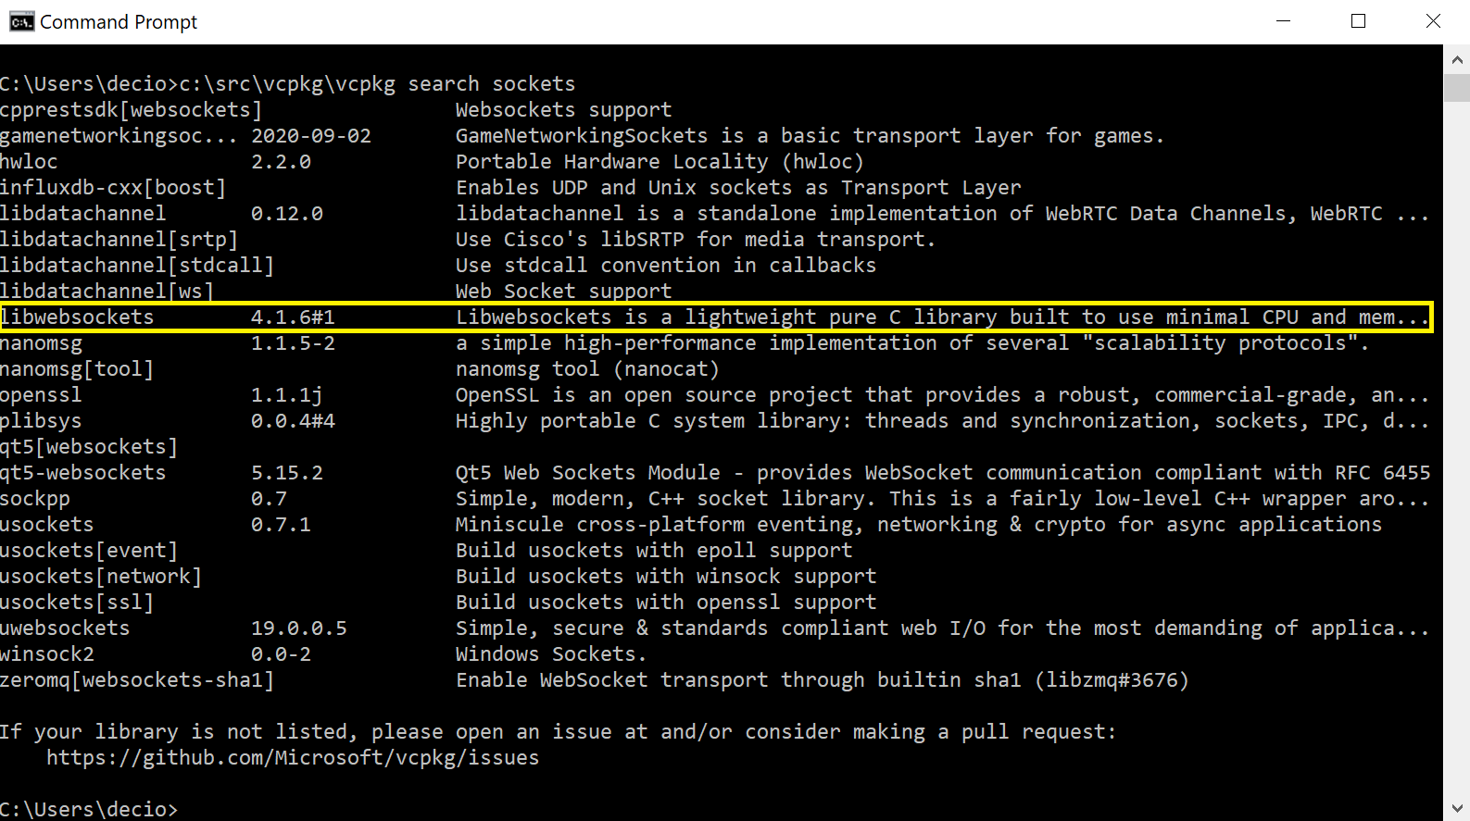
On the above screen, we can check the name of the libwebsockets.

Export: It's inefficient to make everyone on a team download and build common libraries. A single team member can use the vcpkg export command to create a common zip file of the binaries and headers, or a NuGet package. Then, it's easy to share it with other team members.
c:\src\vcpkg\vcpkg export

Update/Upgrade: The public catalog is kept up to date with the latest versions of the libraries. To determine which of your local libraries are out-of-date, use vcpkg update.
When you're ready to update your ports collection to the latest version of the public catalog, run the vcpkg upgrade command.
It automatically downloads and rebuilds any or all of your installed libraries that are out of date.
By default, the vcpkg upgrade command only lists the libraries that are out of date; it doesn't upgrade them. To actually upgrade the libraries, use the --no-dry-run option.
c:\src\vcpkg\vcpkg upgrade --no-dry-run

vcpkg and Visual Studio: In order to use vcpkg with Visual Studio, run the following command (may require administrator elevation):
c:\src \vcpkg\vcpkg integrate install

Remove: remove one package installed. Not that when we install a package with dependencies, all dependent package is automatically installed. During the removal each package should be removed individually.
c:\src \vcpkg\vcpkg remove <library_name>

Installing a library from the vcpkg repository
After you get the name of a library by using vcpkg search, you use vcpkg install to download the library and compile it.
vcpkg uses the library's portfile in the ports directory.
If a triplet(*) isn't specified, vcpkg installs and compiles for the default triplet for the target platform: x86-windows, x64-linux.cmake, or x64-osx.cmake.
When the portfile specifies dependencies, vcpkg downloads and installs them too.
After downloading, vcpkg builds the library by using the same build system the library uses. CMake and (on Windows) MSBuild projects are preferred, but MAKE is supported along with any other build system. If vcpkg can't find the specified build system on the local machine, it downloads and installs it.

c:\src\vcpkg\vcpkg install <library name>:<optional target triplet>

(*) Target Triplets describe a platform on which code runs and are a core concept in the GNU build system. They contain three fields: the name of the CPU family/model, the vendor, and the operating system name. You can view the unambiguous target triplet for your current system by running:
Target triplets have this simple structure: machine-vendor-operatingsystem, Example:
x86_64-freebsd
x86-windows
x64-windows

Example: installing the libwebsockets library
c:\src\vcpkg\vcpkg install libwebsockets:x64-windows

